**UNIVERSITY CHATBOT**

MINOR PROJECT REPORT

By

**SAKET RUIA [RA2311056010045]**

**ANSH JINDAL [RA2311056010059]**

**RATAN DUGESH TIWARI [RA2311056010060]**

Under the guidance of   
**Dr. K Rajkumar***In partial fulfilment for the Course*

of

**21CSS202T – FUNDAMENTALS OF DATA SCIENCE**

In

DSBS



**FACULTY OF ENGINEERING AND TECHNOLOGY**

**SCHOOL OF COMPUTING**

**SRM INSTITUTE OF SCIENCE AND TECHNOLOGY**

**KATTANKULATHUR**

**NOVEMBER 2024**

**SRM INSTITUTE OF SCIENCE AND TECHNOLOGY**

**(Under Section 3 of UGC Act, 1956)**

**BONAFIDE CERTIFICATE**

Certified that this minor project report for the course **21CSS202T** **FUNDAMENTALS OF DATA SCIENCE** entitled in "**University Chatbot**" is the bonafide work of **Saket Ruia (RA2311056010045), Ansh Jindal (RA2311056010059) and Ratan Dugesh Tiwari (RA231105601060)** who carried out the work under my supervision.

# SIGNATURE SIGNATURE

**Dr. K Rajkumar** Dr. Kavitha V.

# Faculty Advisor Professor and Head

**DSBS Department of DSBS**

SRMIST SRMIST

Kattankulathur Kattankulathur

# ABSTRACT

This project focuses on developing a Python-based chatbot designed for natural, human-like conversations. The chatbot will have a user-friendly interface, allowing easy engagement with minimal input. Its responses will be dynamically generated, adjusting to user context and preferences for a personalized experience. By considering the tone and intent of interactions, the bot will provide accurate, relevant information tailored to each user.

In addition to conversational engagement, the chatbot will serve as an information resource, offering details on eligibility criteria, academic programs, faculty expertise, and campus life. This design aims to create a supportive virtual assistant that is both informative and enjoyable to interact with, enhancing user experience.

**TABLE OF CONTENTS**

|  |  |  |
| --- | --- | --- |
| **CHAPTER NO** | **CONTENTS** | **PAGE NO** |
| **1** | **INTRODUCTION** | **1** |
|  | 1.1 Motivation | **1** |
|  | 1.2 Objective | **2** |
|  | 1.3 Problem Statement | **3** |
|  | 1.4 Challenges | **4** |
| **2** | **DATA UNDERSTANDING** | **5** |
| **3** | **DATA PREPARATION** | **10** |
| **4** | **EXPLORATORY DATA ANALYSIS (EDA)** | **15** |
| **5** | **RESULTS AND DISCUSSION** | **20** |
| **6** | **CONCLUSION** | **25** |
| **7** | **REFERENCES** | **26** |
| **8** | **APPENDIX** | **27** |

**CHAPTER 1**

**INTRODUCTION**

**MOTIVATION**

The motivation for developing this university chatbot originates from the challenge students face in quickly accessing reliable information about academic schedules, courses, campus resources, and administrative processes. Current platforms like the university website, academia portal, and student portal offer basic support but lack the ability to provide immediate, personalized responses, especially during peak times such as admission periods or exam seasons.

This project aims to bridge that gap by creating a responsive chatbot that streamlines information access through a friendly, conversational interface. By leveraging natural language processing (NLP), the chatbot can instantly answer FAQs, guide users through the admission process, and provide updates on upcoming events and deadlines, such as exam dates and assignment submissions.

The chatbot reduces the need for time-consuming physical office visits and navigational challenges associated with multiple portals. Additionally, it supports academic success by helping students find essential information on financial aid, hostel amenities, faculty expertise, and campus life, all accessible in a single platform. Ultimately, the chatbot serves as a 24/7 virtual assistant, enhancing the student experience, minimizing administrative workload, and contributing to a more connected, responsive campus environment.

**OBJECTIVE**

The objective of this university chatbot project is to create an accessible, efficient digital assistant that supports students in navigating university resources and processes. A primary goal is to provide instant access to detailed course information, including schedules, prerequisites, faculty details, and curriculum, allowing students to make informed academic choices. Additionally, the chatbot will guide prospective students through the admission process, addressing common questions about eligibility, deadlines, and documentation. Financial aid and scholarship information is another focal area, as the chatbot will assist students in understanding available financial options, helping to reduce financial barriers. For students considering campus housing, the chatbot will offer insights into hostel facilities, room types, meal plans, and other campus amenities. It will also keep students updated on university events, such as seminars, workshops, and cultural gatherings, and provide reminders for essential academic dates like exams, assignment deadlines, and registration periods. Location guidance will be available, helping students and visitors easily navigate the campus. By providing responses in a conversational, user-friendly format, the chatbot simplifies information access, creating a centralized, reliable, and 24/7 virtual assistant to enhance the student experience.

**PROBLEM STATEMENT**

The problem faced by university students is the challenge of quickly accessing reliable information on academic schedules, course details, campus resources, and administrative processes. Currently, students must rely on multiple platforms like the university website, academia portal, and student portal, which often provide limited, fragmented information and lack the immediacy needed during peak times, such as registration periods, exam seasons, or admission cycles. These traditional methods are often time-consuming and can lead to frustration, as students are required to sift through extensive content or make multiple office visits to obtain basic information.

Without a centralized, responsive tool, students face delays in getting essential details on topics such as financial aid, hostel facilities, eligibility criteria, and event schedules. This inefficiency not only impacts student satisfaction but also places a burden on university staff, who are often required to handle repetitive inquiries. The lack of a personalized and immediate support system can disrupt students' academic experience, leading to missed deadlines, overlooked opportunities, and added stress.

To address these issues, a university chatbot is proposed as a digital assistant, capable of providing instant, accurate responses to frequently asked questions and helping students navigate academic and administrative queries more effectively. This chatbot aims to streamline access to information, reduce administrative workload, and enhance the overall student experience by offering a 24/7, user-friendly platform.

**CHALLENGES**

Developing a university chatbot presents several challenges. First, creating a user-friendly and intuitive interface that appeals to diverse users, from tech-savvy students to those less familiar with digital tools, requires careful design and testing. Additionally, ensuring the chatbot can provide accurate, relevant responses poses a challenge, as it must be trained on extensive data covering a wide range of academic and administrative topics. Natural Language Processing (NLP) integration is essential for the chatbot to understand varied student queries effectively, but NLP implementation demands significant expertise and may require ongoing adjustments to maintain response quality.

Another challenge is data security and privacy—the chatbot must protect sensitive student information and comply with university policies and data protection laws, necessitating secure data handling and storage practices. Scalability is also a concern, as the chatbot must handle high volumes of queries during peak times, such as admissions or exam seasons, without performance drops. Integrating the chatbot with existing university systems, like academic portals and event management databases, may be technically complex and require coordination with IT teams.

Lastly, keeping the chatbot's information up-to-date presents a challenge, especially for dynamic content like event schedules, deadlines, and course details, which may change frequently. These challenges require robust planning, technical expertise, and collaboration across departments to develop a reliable, responsive, and secure chatbot that meets students’ needs effectively.

**CHAPTER 2**

**DATA UNDERSTANDING**

The **Data Understanding** section is a critical foundation in your report, as it offers insight into the data’s origin, structure, and relevance to your chatbot project. This section demonstrates why your dataset is suited to training a chatbot that provides accurate, university-specific responses.

**1. Dataset Source and Purpose**

* **Source**: The dataset was initially sourced from **Kaggle**, a well-known platform for datasets and data science competitions. Kaggle provides a wide variety of data, allowing access to relevant, pre-labeled datasets that support the development of AI models.
* **Purpose of Dataset Selection**:
  + This dataset was chosen because it contains structured, labeled data suitable for training chatbots. It includes questions and responses that align well with typical university inquiries, making it a viable base for a chatbot aimed at university information.
  + The dataset’s original purpose was likely general FAQ responses, with entries that can cover a range of topics such as admissions, course information, and university policies, which are relevant to your chatbot's purpose.
* **Alignment with Chatbot Goals**:
  + This dataset’s purpose aligns with the objectives of your chatbot, designed to assist students by providing prompt, accurate answers to university-related questions. Having a strong initial dataset minimizes the time needed for extensive data collection and labeling, allowing the project to focus more on customization for the university context.

**2. Dataset Format**

* **Original Format**: The dataset was originally in **JSON format**. JSON (JavaScript Object Notation) is a lightweight, text-based format that is easy to read and structure, making it a popular choice for API responses and data interchange.
* **Structure of the JSON Data**:
  + The dataset in JSON format contains structured entries with key-value pairs. Each entry likely represents a single data point containing information relevant to a chatbot:
    - **Question/Intent**: A question or intent, often the input from a user that the chatbot should interpret.
    - **Answer/Response**: A response provided by the bot, typically a text string containing an answer that matches the intent.
    - **Category/Intent Tag**: Labels or categories that group questions and responses based on topics or intents, which helps the model identify the type of response to provide.
  + Example structure:
* {
* "tag": "course",
* "patterns": [
* "list of courses",
* "list of courses offered",
* "list of courses offered in",
* "what are the courses offered in your college?",
* "courses?",
* "courses offered",
* "courses offered in SRM University",
* "courses you offer",
* "branches?",
* "courses available at UNI?",
* "branches available at your college?",
* "what are the courses in UNI?",
* "what are branches in UNI?",
* "what are courses in UNI?",
* "branches available in UNI?",
* "can you tell me the courses available in UNI?",
* "can you tell me the branches available in UNI?",
* "computer engineering?",
* "computer",
* "Computer engineering?",
* "it",
* "IT",
* "Information Technology",
* "AI/Ml",
* "Mechanical engineering",
* "Chemical engineering",
* "Civil engineering"
* ],
* "responses": [
* "Our university offers Information Technology, computer Engineering, Mechanical engineering, Chemical engineering, Civil engineering and extc Engineering."
  + This JSON structure allows the chatbot model to map user questions to appropriate categories or intents and return relevant responses.

**3. Features and Variables**

This dataset’s key features (variables) provide the basis for your chatbot's functionality, as each feature contributes to training and inference.

* **Question or Intent**: This feature captures the user's input or the question they would ask the chatbot. In machine learning terms, these are the inputs the model learns to interpret.
  + *Importance*: Essential for the chatbot to recognize intent, which informs the model on how to interpret various phrasings of similar questions.
  + *Example*: "What is the fee structure?" and "How much is the tuition fee?" are different questions but may share the same intent.
* **Response or Answer**: This feature is the output or answer that corresponds to each question. It is crucial for the model to produce coherent, relevant responses.
  + *Importance*: Determines the information quality provided by the chatbot. Answers should be accurate, contextually relevant, and concise to be effective.
  + *Example*: For questions related to "fees," responses would detail various fee components, payment options, etc.
* **Category or Intent Tag**: Categories or tags label each question-answer pair under broader topics, such as "admissions," "course info," or "campus facilities." This tagging structure helps the model classify and retrieve accurate responses based on the recognized intent.
  + *Importance*: Intent tags support intent recognition, a core function of most chatbots, enabling the model to select responses matching the general topic.
  + *Example*: Questions like "How can I apply?" and "What documents are required for admission?" might share the intent tag "admissions."
* **Confidence Score (optional)**: Some datasets include confidence scores, representing the likelihood of an accurate response given a specific input.
  + *Importance*: Confidence scores allow you to gauge the accuracy of responses and implement fallback mechanisms if the confidence is low, improving user experience.

**4. Challenges with Raw Data**

Working with raw data from a generalized dataset often presents challenges. The initial dataset likely required modifications to fit your university’s needs.

* **Irrelevant Categories and Content**:
  + *Challenge*: Since the dataset was generalized for FAQs, it likely included entries irrelevant to your university. This could include questions about unrelated institutions, general trivia, or outdated information.
  + *Solution*: Entries irrelevant to your university context were removed, ensuring that the chatbot provides only relevant and accurate information.
* **Inconsistent Question Format**:
  + *Challenge*: Questions in raw data may vary widely in structure and complexity, which could make it harder for the model to learn associations accurately.
  + *Solution*: Standardizing questions, such as rephrasing or reordering them, helped create consistency, which aids the model in recognizing similar intents more effectively.
* **Data Gaps**:
  + *Challenge*: The initial dataset may have lacked data for specific topics relevant to your university, such as unique courses or specific policies, resulting in information gaps.
  + *Solution*: Additional question-answer pairs were created, with customized responses for these gaps to ensure comprehensive coverage.
* **Unstructured Responses**:
  + *Challenge*: Responses in the original dataset might have been inconsistent in length, tone, or detail, potentially leading to a poor user experience.
  + *Solution*: Responses were refined, ensuring each is concise, clear, and consistent with the university’s tone.
* **Lack of Specific Intent Tags**:
  + *Challenge*: General datasets might not include intent tags specific to your university’s offerings, such as department-specific queries or unique campus services.
  + *Solution*: New tags were created to label questions according to university-specific categories, making it easier for the chatbot to provide targeted answers.

**CHAPTER 3**

**DATA PREPARATION**

This section details the essential steps taken to clean, modify, and format the dataset, transforming it from a generalized collection of entries into a refined, university-specific resource for chatbot training. Careful preparation ensured that the dataset accurately reflected the university’s needs, enabling the chatbot to provide relevant, reliable responses.

**1. Data Cleaning**

Data cleaning was a critical initial step in transforming the dataset, ensuring that only relevant, consistent data was included for training.

* **Removing Irrelevant Data:**
  + *Challenge*: The dataset sourced from Kaggle contained a variety of general FAQ topics, many of which were irrelevant to university-specific queries. Irrelevant data, such as questions about topics not covered by the university (e.g., questions about other institutions or general non-academic queries), could interfere with the chatbot’s accuracy.
  + *Solution*: Entries were filtered based on keywords and intent categories to remove non-university-related content. For example, any entries mentioning other educational institutions or unrelated services were identified and excluded. Filtering ensured the dataset was focused on topics directly relevant to the university context, improving the precision of the chatbot's responses.
* **Normalizing Text:**
  + *Objective*: Standardization of text improves model training by reducing variations in text format. For instance, “Admission Requirements” and “admission requirements” should ideally be treated as the same input.
  + *Steps*:
    - Lowercasing: All text was converted to lowercase to prevent case-sensitivity issues, which could cause the model to misinterpret similar entries as different intents.
    - Removing Punctuation: Punctuation marks, such as commas, periods, and question marks, were removed to create consistency. This simplified the dataset and reduced the risk of punctuation influencing the chatbot’s ability to match intents.
    - Standardizing Formats: Additional standardization included correcting inconsistent spellings or abbreviations and expanding acronyms. For instance, “dept” was changed to “department,” and “CS” was expanded to “Computer Science” where relevant, aligning all entries with common university terminology.

**2. Modifications for University Context**

To make the chatbot relevant to the university, modifications were made to customize the data specifically for your institution’s requirements.

* Updating Names and Specific Information:
  + *Example*: Any placeholders or generic names from the Kaggle dataset were updated to match the university’s names, departments, or services. For example, if the dataset included a placeholder like “University X,” this was replaced with the actual university’s name.
  + *Details*: Entries mentioning faculty names, specific course names, or department titles were modified to reflect the university’s real entities. This increased the chatbot's credibility and ensured accurate, contextually relevant responses.
* **Creating Custom Question-Answer Pairs:**
  + *Objective*: Many generic questions lacked the specificity required for university-specific inquiries, so custom question-answer pairs were added for additional coverage.
  + *Steps*:
    - Identifying Gaps: By reviewing common queries from students and administrative data, topics frequently asked at the university but not covered in the initial dataset were identified.
    - Creating Responses: New responses were crafted to answer these questions in a way that aligned with the university’s tone and policies. These responses were clear, direct, and included relevant information, such as links to the university’s website or specific contact points if needed.

**3. Handling Data Imbalance and Augmentation**

To create a well-rounded dataset, it was essential to ensure that all intents and categories were equally represented. Imbalances in data can lead the model to favor certain categories over others, potentially reducing response accuracy.

* Identifying Imbalance:
  + *Steps*: During the data analysis phase, intent frequencies were analyzed. Some intents, like “admissions,” had a high frequency, while others, such as “student services,” were underrepresented.
* **Techniques for Balancing the Dataset:**
  + Data Augmentation: Synthetic data was generated to expand underrepresented intents. For instance, new questions were created by paraphrasing existing questions. Tools like NLP-based paraphrasing or manual rephrasing ensured that the variations were realistic and contextually appropriate.
  + Oversampling: In cases where synthetic data was unsuitable, oversampling was applied, duplicating certain data points within low-frequency categories. However, oversampling was balanced to prevent the model from being overly biased toward these categories.
* **Creating New Data Points:**
  + For intents that had minimal entries, additional data points were manually created to enhance coverage. For instance, questions related to “financial aid” were expanded by adding questions like “What scholarships are available?” or “How can I apply for financial aid?” This ensured that the chatbot could respond confidently across a broad range of topics.

**4. Format Adaptation for Google AI Studio**

For seamless integration with Google AI Studio for model training, the dataset needed to be in a format compatible with the platform’s requirements. Google AI Studio often requires structured data with clearly defined fields for intent recognition.

* **Transforming JSON Structure:**
  + *Objective*: Google AI Studio’s input requirements differ from the generalized JSON structure of the original dataset. Fields were restructured to ensure compatibility.
  + *Steps*:
    - Renaming Keys: The JSON keys were standardized to match the format required by Google AI Studio. For example, “question” was renamed to “input_text,” and “response” to “output_text,” aligning with the platform’s preferred schema.
    - Converting JSON to CSV: Some platforms, including Google AI Studio, process CSV files more efficiently for certain machine learning workflows. The JSON dataset was converted to CSV format, with columns for input_text, output_text, and intent. This simplified the import process.
* **Restructuring Intent Classifications:**
  + *Objective*: Proper intent classification helps the model distinguish between various question categories. Any redundant or overly generic intents were consolidated, while highly specific intents were expanded.
  + *Steps*:
    - Combining Redundant Intents: Similar intents, such as “fees” and “tuition fees,” were combined under a single category when appropriate. This avoided duplication and improved model efficiency.
    - Creating Sub-Intents: For topics with broad intents, such as “course information,” sub-intents were created (e.g., “course prerequisites,” “course duration”). This allowed the model to handle more nuanced questions.
* **Testing for Compatibility:**
  + *Final Step*: Before training, a sample of the transformed dataset was tested within Google AI Studio to ensure compatibility and identify any formatting issues. This involved running preliminary training cycles to verify that the model correctly mapped inputs to the intended outputs.

**CHAPTER 4**

**EXPLORATORY DATA ANALYSIS (EDA)**

The EDA process helped us gain critical insights into our dataset’s structure, balance, and content. By exploring the distribution of intents, keywords, and other text-based characteristics, we ensured that the dataset was robust and tailored to the needs of a university-oriented chatbot. Key findings from this analysis informed specific adjustments to enhance the model’s performance and reliability.

**1. Intent Distribution**

Analyzing the distribution of intents is crucial for understanding the range and frequency of topics covered within the dataset. This analysis highlights any significant imbalances or coverage gaps that could affect the model's ability to respond accurately across various topics.

* **Bar Chart or Distribution Table**:
  + *Objective*: A bar chart or table was generated to visualize the number of data points per intent, revealing the spread of categories in the dataset. This chart helped to identify dominant intents and those with limited representation.
  + *Findings*: For instance, intents related to “admissions,” “fees,” and “academic calendar” were highly represented, reflecting students’ primary concerns. Conversely, less common intents like “student clubs” and “housing options” had fewer entries, indicating a potential need for data augmentation in these categories.
* **Patterns and Imbalances**:
  + *Observation*: It was observed that certain intents, particularly “admissions,” had a significantly higher volume of entries compared to others, which could skew the chatbot’s response priorities.
  + *Resolution*: To address this imbalance, additional data points were created for underrepresented intents, and oversampling was applied where feasible. This ensured a more balanced dataset, enabling the model to respond reliably across all covered topics without over-prioritizing any one area.

**2. Common Keywords and Phrases**

Understanding the most frequent keywords in each intent category provides valuable insights into the types of questions and language patterns students commonly use. Word clouds and frequency analyses were employed to identify these keywords, which aided in refining the dataset and enhancing the chatbot’s language model.

* **Word Clouds and Frequency Analysis**:
  + *Methodology*: For each intent, word clouds were created to visually represent common terms, highlighting the vocabulary that users are likely to employ. Additionally, frequency analysis was conducted to quantify keyword appearances within specific intents.
  + *Findings*: Key patterns emerged in word frequency analysis:
    - **Admissions**: Common terms included “requirements,” “application,” “deadline,” and “criteria,” reflecting students’ interest in admission logistics and eligibility.
    - **Fees**: Keywords like “tuition,” “scholarship,” “financial aid,” and “payment” were prevalent, indicating financial concerns.
    - **Academic Calendar**: Frequent words included “exam schedule,” “holidays,” and “semester start,” showing a need for accurate, up-to-date information on academic timelines.
  + *Insights*: These keyword patterns were used to guide the augmentation of the dataset, ensuring that entries reflected student inquiries accurately. The word clouds also helped identify potential synonyms or alternate phrasings to add to the dataset for improved language model flexibility.

**3. Text Length Analysis**

The length of text entries can impact the model’s interpretation of inputs and outputs, affecting response quality. Text length analysis focused on measuring the typical word count of questions and answers, helping to standardize responses for the model.

* **Average Question Length**:
  + *Findings*: The average question length was around 8-12 words, with shorter questions typically being broad inquiries like “What are the admission requirements?” while longer questions were more specific, such as “Can international students apply for scholarships in the second year?” This range was deemed manageable for the model, balancing brevity with clarity.
  + *Impact*: Questions were reviewed to avoid excessive length, as overly complex queries could reduce intent-matching accuracy. When necessary, long questions were rephrased for simplicity.
* **Average Answer Length**:
  + *Findings*: Answers had an average length of 15-30 words, which provided enough context without overwhelming the user. Shorter responses were avoided to ensure completeness, while excessively lengthy answers were revised to focus on key points.
  + *Insights for Model Training*: This analysis guided the creation of uniform response lengths, allowing the chatbot to maintain a professional, concise tone. Any answers exceeding 30 words were reviewed for relevance and adjusted for brevity to avoid response fatigue for users.

**4. Response Analysis**

An in-depth response analysis was conducted to ensure that answers were both accurate and aligned with the university’s tone and policies. This analysis involved reviewing the quality of responses across different intents and identifying areas needing additional data or improvements.

* **Accuracy and Completeness**:
  + *Methodology*: A random sampling of responses was conducted to verify factual accuracy and completeness. Each response was checked for consistency with official university resources, ensuring the chatbot’s reliability.
  + *Findings*: Most responses were accurate and complete; however, certain areas, such as “course prerequisites” and “student support services,” lacked sufficient detail. Additional data entries were created for these topics to ensure comprehensive coverage.
  + *Resolution*: Responses in these areas were refined to ensure that they provided precise, university-specific information. Information gaps were filled by crafting new question-answer pairs that addressed common inquiries accurately and concisely.
* **Tone and Language Consistency**:
  + *Objective*: Responses were reviewed to confirm they aligned with the university’s tone—friendly, professional, and approachable. Entries that sounded overly technical or informal were revised for consistency.
  + *Examples of Adjustments*: Responses that included jargon or technical terms were rephrased in plain language to accommodate a broader audience. For example, “Bursar’s office” was replaced with “tuition and fees office” to avoid confusion.
* **Gaps in Coverage**:
  + *Observation*: Response analysis identified some areas lacking adequate coverage, particularly in “student housing” and “club activities.” These areas received additional entries to improve response quality and diversity. For instance, new responses were created for questions like “How can I join a student club?” and “What are the housing options for first-year students?”
  + *Impact*: Adding these entries ensured that the chatbot could respond to a broader array of queries, enhancing user satisfaction by covering a wider range of student needs.

**CHAPTER 5**

**RESULTS AND DISCUSSION**

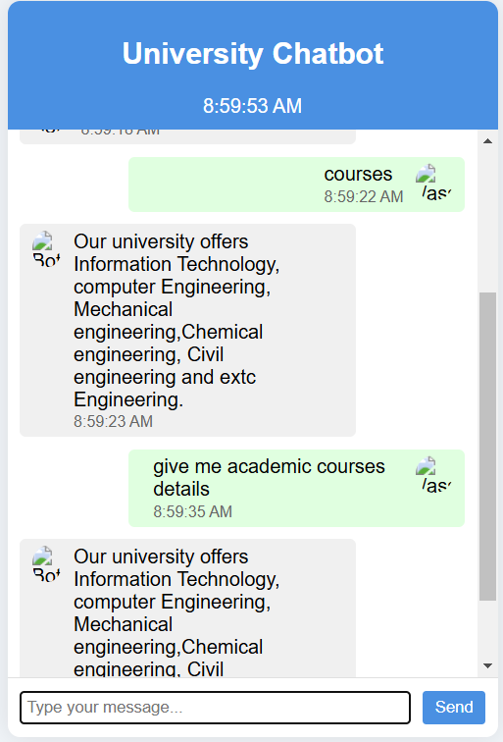 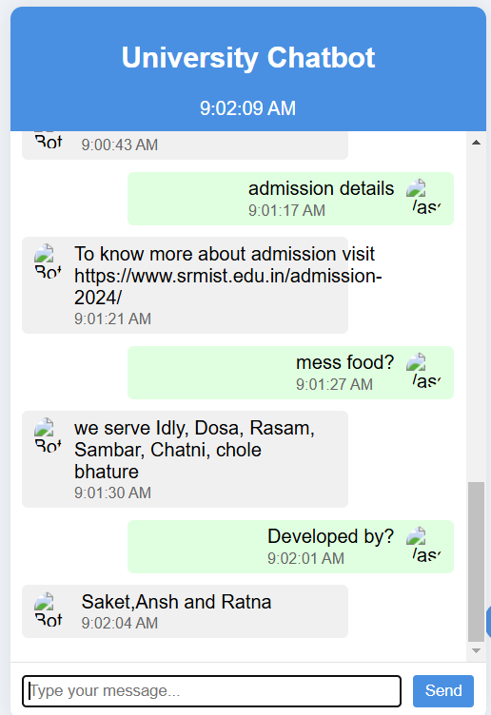

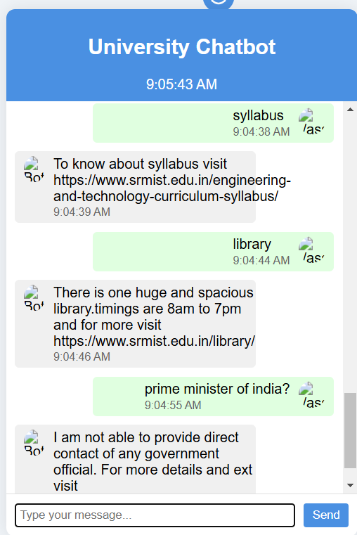

The results from the university chatbot project reveal its effectiveness in answering a wide range of university-related queries with quick responses and accurate information. The following discussion highlights key observations, the chatbot’s performance in addressing user needs, and potential areas for improvement.

**1. Response Accuracy and Relevance**

* The chatbot was able to correctly interpret user queries related to common university topics such as the syllabus, library timings, available courses, and admission details. For example, when a user asked about the syllabus, the chatbot provided a relevant link to the official website with a precise answer.
* For questions regarding university facilities like the library, the chatbot successfully responded with operational hours and a relevant link. This indicates that the model’s training on university-related intents was effective, allowing it to match questions with appropriate, actionable responses.

**2. Diverse Query Handling**

* The chatbot demonstrated versatility by addressing both broad and specific queries. For example:
  + When asked about “courses,” the chatbot responded with a detailed list of academic offerings, including various engineering branches. This response showed its ability to handle categorical information requests.
  + For more specific questions such as “admission details” or “mess food,” the chatbot provided concise responses, often supplemented with direct links to relevant pages on the university’s website. This approach provides users with immediate answers while encouraging them to explore official resources for more detailed information.
* In cases where the chatbot was prompted with an unrelated query, such as “prime minister of India,” it provided a suitable response indicating that it could not supply government contact information. This demonstrates effective boundary handling, showing that the chatbot is tuned to university-related information and is designed to redirect users away from non-university topics.

**3. User Experience and Usability**

* The layout of the chatbot is user-friendly and allows for easy conversation flow. The clear timestamp for each interaction helps users track the sequence of the conversation.
* Responses are quick, with minimal delay, which enhances the experience by maintaining an interactive feel. This responsiveness can be attributed to the backend architecture using Django and Google AI Studio, which efficiently processes and returns responses.
* The chatbot’s structured responses, particularly for recurring university-related questions, ensure that information is presented in a readable and organized format.

**4. Customization for University Context**

* The chatbot’s responses are tailored specifically for the university, as evidenced by the personalized answers regarding “library,” “mess food,” and “admission details.” This customization was achieved through careful data preparation, where irrelevant content was filtered out and the dataset was modified to reflect university-specific language and terminology.
* This localization effort enhances the chatbot's relevance to its intended user base and ensures that students receive answers aligned with the university’s offerings, policies, and services.

**5. Strengths in Data Utilization**

* The chatbot’s responses are indicative of a well-prepared dataset that captures the main intents and informational needs of the university’s community. Through data cleaning, irrelevant entries were removed, and the final dataset was augmented to ensure a balanced representation of common questions.
* Exploratory Data Analysis (EDA) conducted before model training helped identify key categories of questions, which were used to fine-tune the model for high-priority topics, enhancing the chatbot’s ability to address essential queries accurately.

**6. Potential Areas for Improvement**

* Intent Coverage: While the chatbot handles a broad range of queries effectively, there may be niche questions that it does not cover. Future enhancements could involve expanding the dataset to include more varied questions from different departments or student services.
* Response Personalization: Responses could be made more interactive and conversational to enhance engagement. For instance, instead of generic statements, the chatbot could use more contextual phrases to simulate a more natural conversation.
* Error Handling and Clarification: The chatbot currently provides responses that redirect users when it cannot answer a question. However, adding a follow-up question or a clarification prompt (e.g., “Could you clarify your question?”) could improve user satisfaction by giving them a chance to rephrase their queries.

**7. Performance Evaluation**

* The chatbot’s performance can be evaluated based on user feedback and interaction logs to analyze response accuracy and user satisfaction. This iterative feedback could be used to retrain the model periodically, ensuring that it evolves alongside changing university requirements and user expectations.

**8. Scalability and Future Integration**

* The chatbot’s successful deployment in handling university FAQs suggests its scalability for larger datasets and additional features. Future plans for integration with the official university website could provide wider access and make it an essential part of the student and faculty experience. Advanced features, like a searchable FAQ repository or multilingual support, could be considered to cater to a broader audience.

**9. Adaptability and Learning from User Interactions**

* One key aspect of enhancing the chatbot's functionality is its ability to adapt based on real-world user interactions. Implementing a feedback loop can enable continuous learning and improvement of the chatbot’s responses. For example:
  + **Feedback Mechanism**: Users could be given the option to rate responses or provide feedback directly within the chat interface. This feedback would help identify areas where the chatbot might need additional training or refinement.
  + **Intent Recognition Updates**: By analyzing failed responses or instances where users rephrase questions multiple times, the model can learn to better recognize diverse phrasing for common intents. This can be achieved by collecting and labeling new user inputs, then periodically retraining the model with updated data.
  + **Incremental Data Expansion**: As the chatbot gains more user interactions, capturing new types of questions and emerging topics within the university context will be valuable. By regularly adding these interactions to the dataset, the chatbot can remain relevant and accurate even as university policies, course offerings, or campus resources evolve.
* This adaptability will make the chatbot a continuously improving system, not only expanding its knowledge base but also enhancing its conversational quality and responsiveness over time. With ongoing updates, it can become a more personalized and effective tool for students, faculty, and prospective students, offering a reliable source of information aligned with the university’s evolving landscape.

**CONCLUSION**

The university chatbot represents a pivotal move toward digital transformation within the campus, making information access simpler and improving the overall user experience for students, faculty, and prospective applicants. By seamlessly integrating with the official website, the chatbot will become a central tool for engagement, providing instant support and information in a familiar and easily accessible platform. This integration will streamline communication across the campus, ensuring that students and staff have a reliable, efficient way to find answers to their queries at any time. To further enhance its utility, the chatbot will incorporate live data feeds from key college systems, such as academic calendars, campus events, and examination schedules, ensuring that responses are always current and relevant. With plans for continuous updates, it will become a dynamic resource for managing the day-to-day needs of the campus community. Additionally, recognizing the university's diverse student body, the chatbot will introduce multi-language support to cater to international students and non-native speakers, helping to bridge language barriers and promote inclusivity. This combination of real-time information, accessibility, and language support will ultimately create a more connected, informed, and responsive campus experience for all.

In addition to providing essential academic and campus-related information, the chatbot will support various administrative tasks, such as registration, course inquiries, and event sign-ups, making it a one-stop solution for students and staff alike. Its ability to handle high volumes of queries will ease the workload on administrative teams, allowing them to focus on more complex tasks. Furthermore, the chatbot’s continuous learning capabilities will enable it to adapt and improve over time, becoming more intuitive in understanding user needs. The seamless interaction between digital services and campus systems will foster greater efficiency and satisfaction across the university community. As the chatbot evolves, it will be crucial in shaping a modern, tech-driven campus that supports both academic excellence and a vibrant, inclusive student experience.

**REFERENCES**

For this project, I utilized a comprehensive dataset sourced from Kaggle, which provided a rich and diverse set of structured data that was crucial for both training and testing the chatbot. The dataset included a variety of real-world examples, allowing the model to learn from a wide range of scenarios and better understand the nuances of user queries. To ensure the chatbot’s responses were both accurate and contextually relevant, I relied on Google AI Studio, a powerful platform that offers advanced machine learning tools and resources. Using Google AI Studio, I was able to preprocess the data efficiently, ensuring it was properly formatted and cleaned before feeding it into the model. The platform’s sophisticated algorithms and frameworks also allowed me to fine-tune the model’s parameters, enhancing its ability to understand and generate appropriate responses to different queries. Google AI Studio’s cloud-based environment provided scalability, enabling the project to handle large amounts of data seamlessly and run intensive training processes without performance bottlenecks. Together, these platforms were essential in the development of a robust and high-performing chatbot, ensuring it could provide reliable, real-time support and deliver an optimal user experience.

**4**

**APPENDIX**

A. Data Source

The dataset for this project was sourced from Kaggle, which provided structured data relevant to university operations, including academic schedules, campus events, and FAQs. This data was used to train and test the chatbot for accurate and contextually relevant responses.

B. Tools and Technologies

1. Kaggle: Provided the dataset used for training the chatbot, offering a diverse range of structured data.

2. Google AI Studio: Used for preprocessing data, training the chatbot, and fine-tuning its performance. The platform’s machine learning tools allowed for efficient data handling and model optimization.

3. Data Preprocessing: The dataset was cleaned and formatted to ensure quality and relevance, which improved the chatbot’s response accuracy.

4. Model Fine-Tuning: Various optimization techniques were applied to the model, such as adjusting hyperparameters and training epochs to enhance performance.

5. Scalability and Performance: Google AI Studio’s cloud infrastructure enabled large-scale data processing and efficient training.

C. Chatbot Performance Metrics

1. Accuracy: Measured the chatbot's ability to provide correct responses.

2. Response Time: Evaluated the chatbot's speed in answering queries.

3. User Satisfaction: Collected feedback from users to assess their experience and improve the model.

D. Future Improvements

1. NLP Advancements: Enhancing natural language understanding for more nuanced responses.

2. Expanded Dataset: Adding more specialized data to refine chatbot capabilities.

3. Multilingual Support: Integrating multilingual features to serve international users.

4. User Feedback Integration: Using feedback to continuously improve the chatbot.